Check cost saving from AWS recommendations

Check trusted advisor report for cost saving.

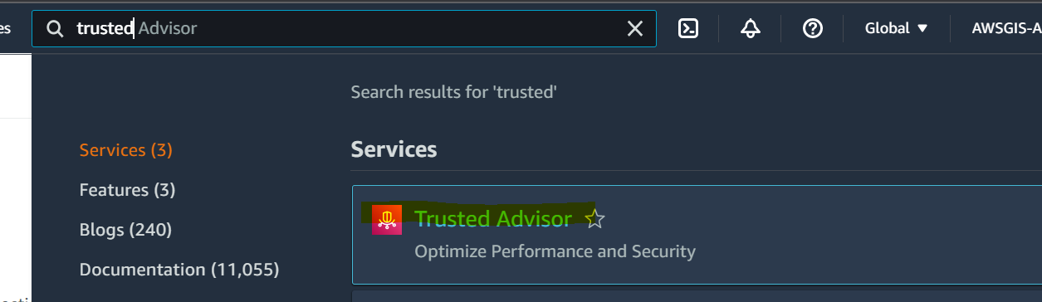

Click on cost optimization.

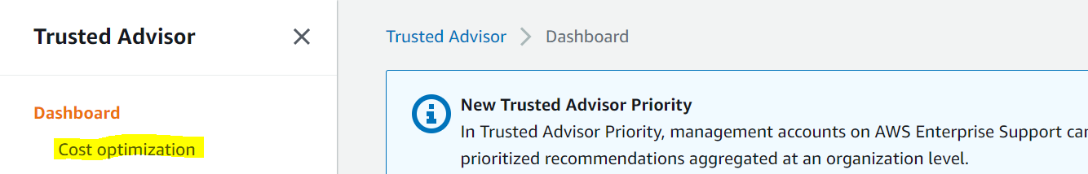

Work on the findings below.

